Screenshots
The prototype will contain four main screens:
Screen 1 — Home and question entry
- HR Ally welcome message.
- Suggested topics such as Leave, Benefits, Attendance, and Salary Documents.
- A text input for natural-language questions.
- A brief notice that answers are based on available approved HR information.
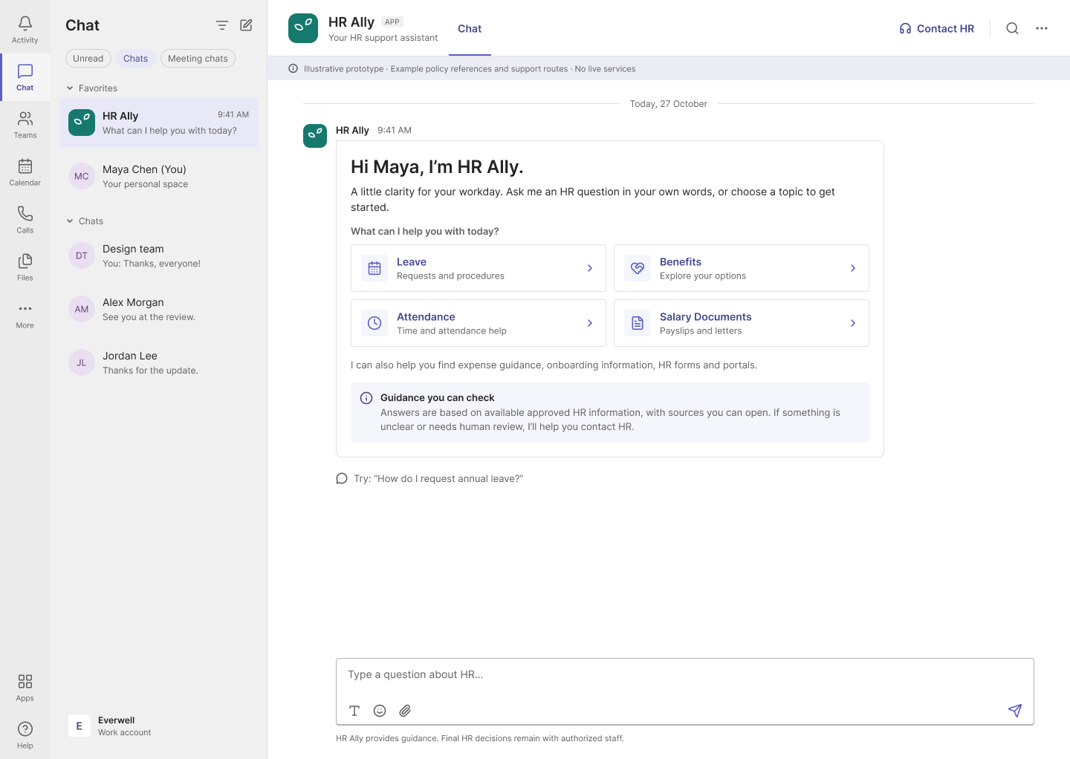
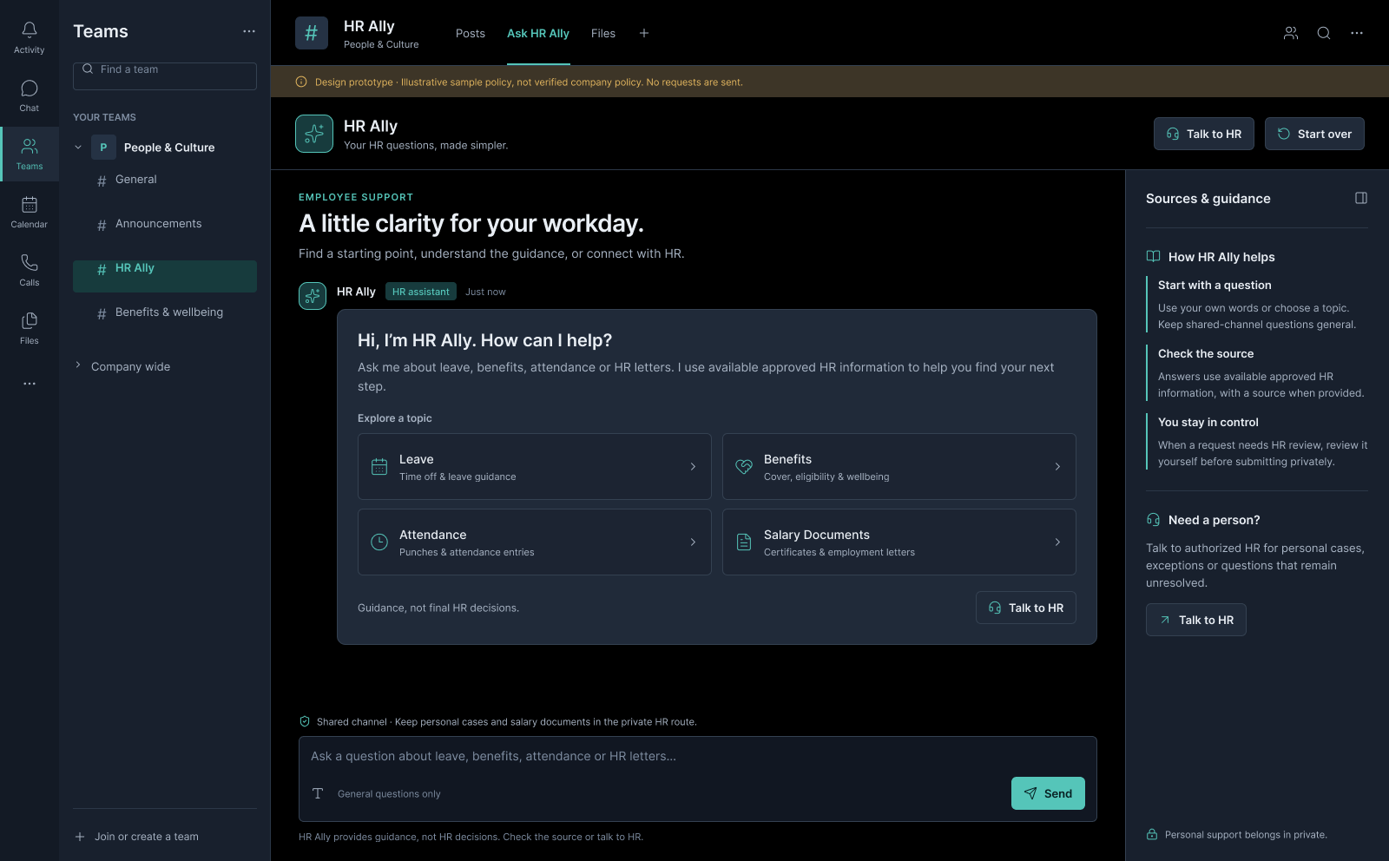

Screen 2 — Answer with source
- The employee's question and the assistant's response.
- The name of the supporting HR policy or document and a link to it.
- A suggested next step, such as opening a form or portal.
- Helpful / Not helpful feedback options.
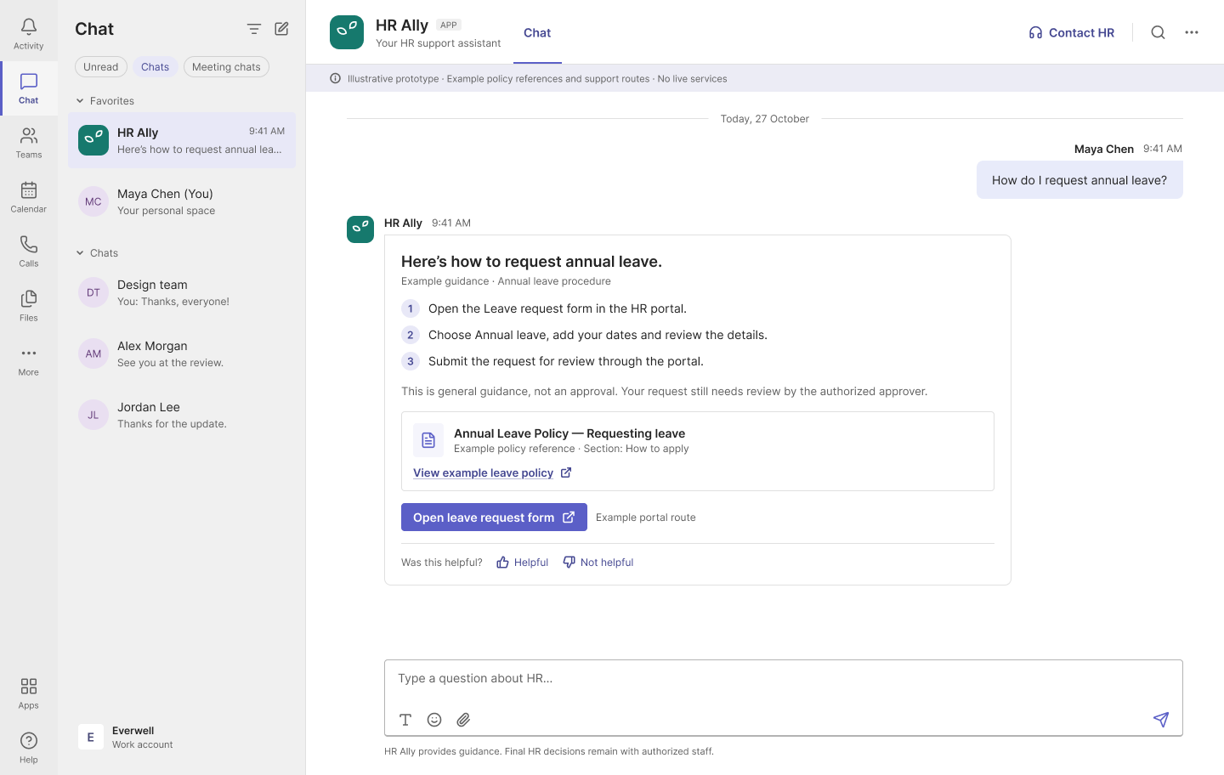
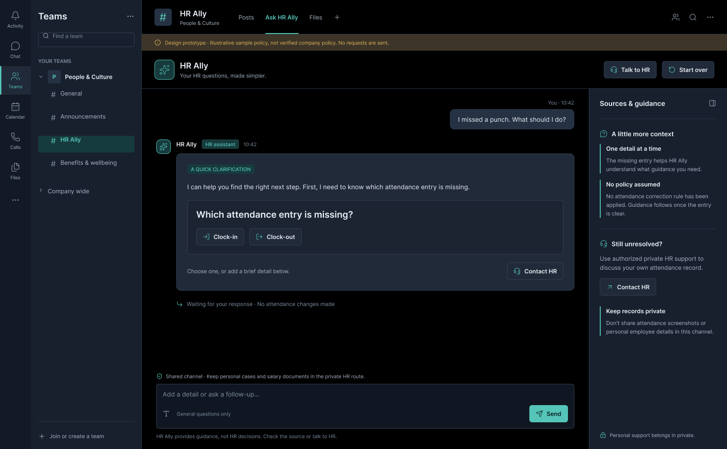

Screen 3 — Clarification
- A short explanation of what information is missing or unclear.
- One focused follow-up question.
- Options to provide the missing detail or contact HR if the issue remains unresolved.
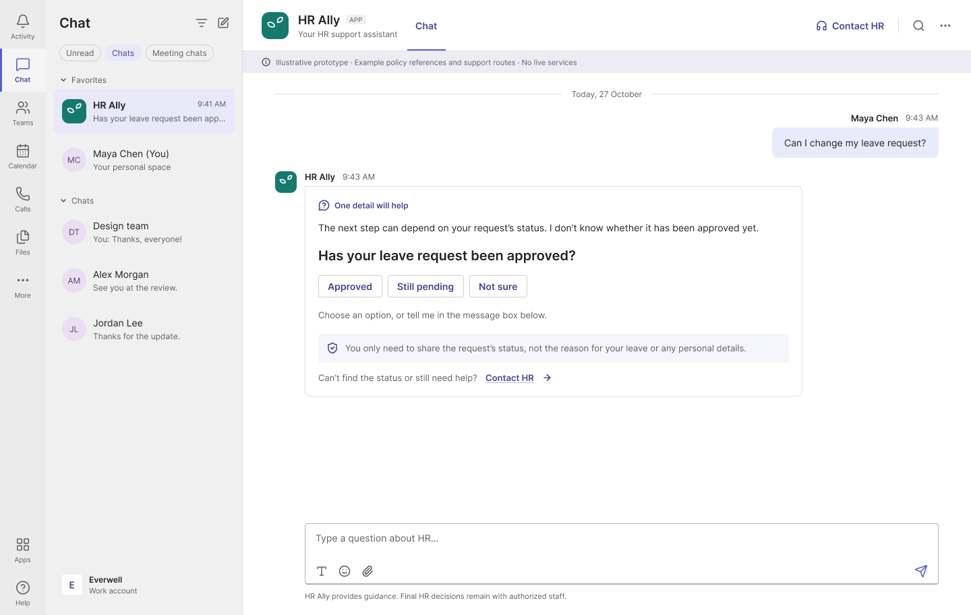
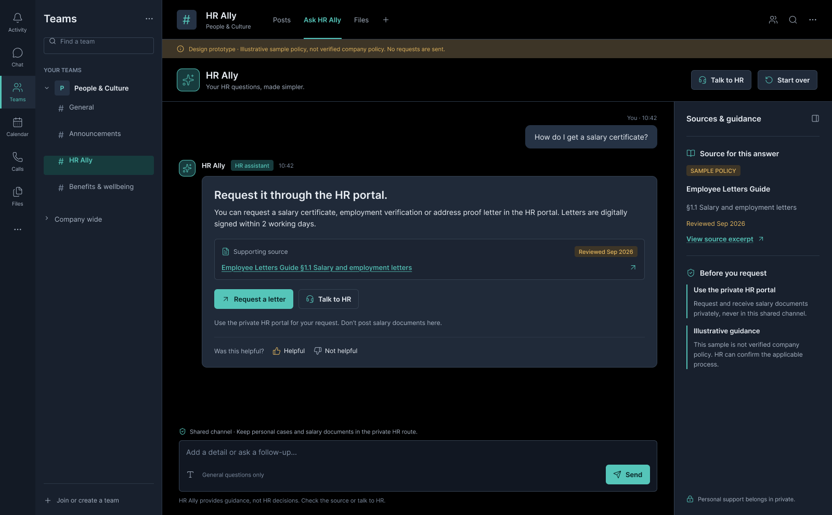

Screen 4 — Escalation and support
- A clear explanation that the assistant cannot reliably resolve the issue or that the matter needs human review.
- A link or route to the appropriate authorized HR support channel.
- A privacy-conscious notice advising the employee not to share unnecessary sensitive information in the chat.


